# Dynamic Design

## ECU 1

### State Machine Diagram

Read Light Sensor

Door state message sent every 10 ms

Light state message sent every 10 ms

Door state message sent every 10 ms

Read Door Sensor

**Door sensor :**

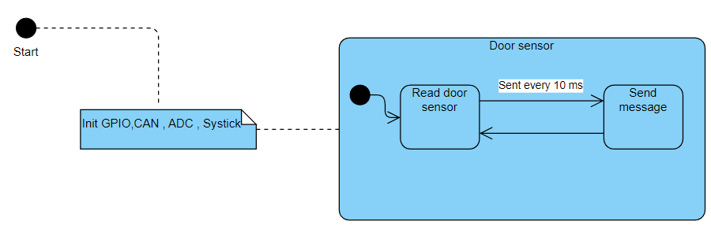

**Light sensor :**

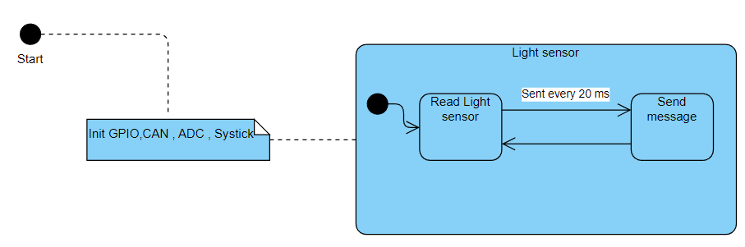

**Speed sensor :**

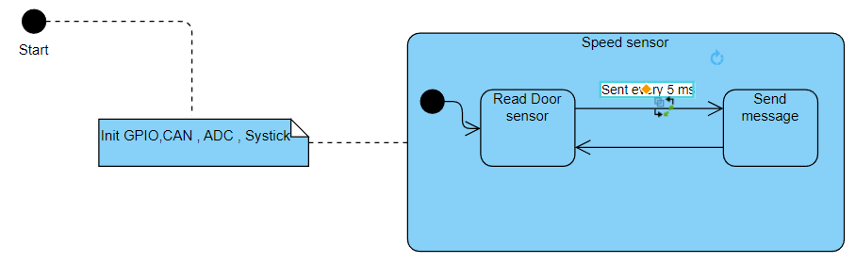

### Sequence Diagram

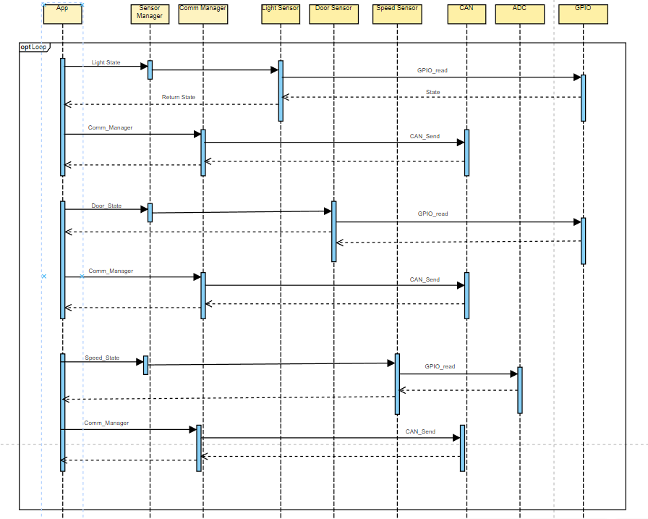

### CPU Load

* Assume execution time of each part of super loop is **1 ms**
* Periodicities of **20, 10, and 5**

CPU Load = ($\frac{\sum{E}}{Hyper period }$) = ($\frac{1+1*2+1*4}{20 }$)*100 = 35 %

## ECU 2

### State Machine Diagram

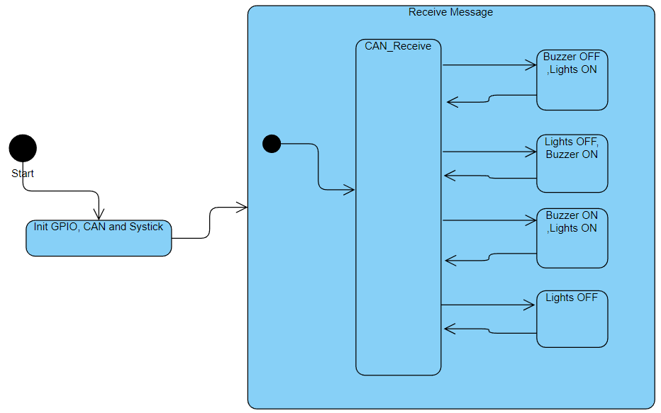

Door closed, Lights are on

- Light switch pressed, Car moving.

- Door opened, car stopped

Light switch pressed, Car stopped

Door open, Car moving

**Lights:** 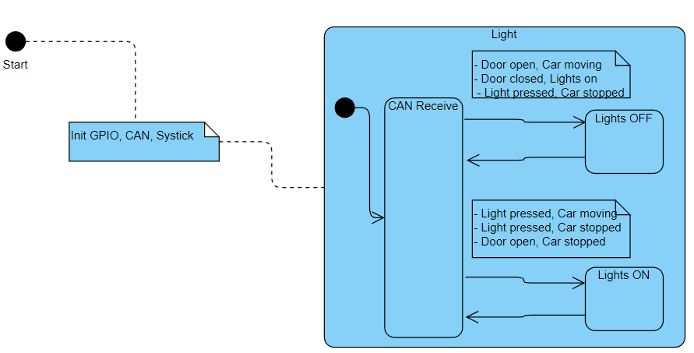

**Buzzer:**

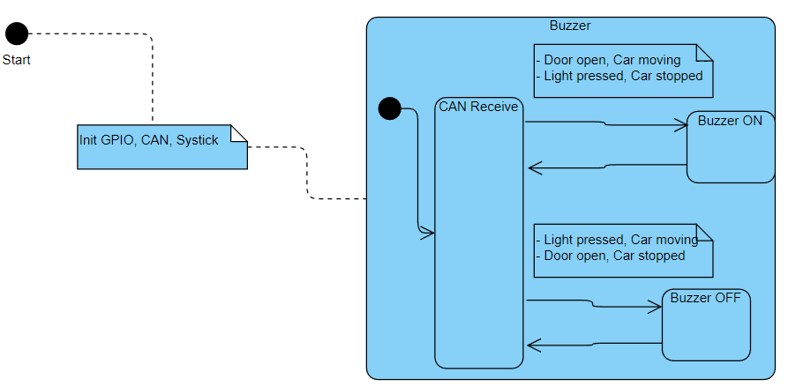

### Sequence Diagram

### CPU Load

* Assume execution time **2 ms** & periodicity of **6 ms**

CPU Load = ($\frac{\sum{E}}{Hyper period }$) = ($\frac{2}{6 }$)*100 = 33 %

### CAN Bus Load

* Assume 1 CAN frame contains ~ 125 bits
* Using 500 Kbit/s bit rate

Bit time = 1 / bit rate = 1 / (500 * 1000) s = 2 * 10-6 s = 2 µs

1 bit will take 2 µs to transfer on bus when using 500 Kbit/s.

Time to transfer 1 frame is (2 µs/bit * 125 bit) = **250 µs**.

We send: **1 frame** every **20, 10, and 5 ms -> 200, 100, 50** frames every **1 s**

Total frames in 1 second is 350 frames

Total time = 350 * 250 = **87500 us**

Bus Load = (87500 * 1000 /1000) * 100 = **8.75 %**